AI ASSISTED CODING LAB TEST 3

NAME– G.SANJANSAH

DATE- 31-10-2025

BATCH – 16

ROLL.NO-2503A52L20

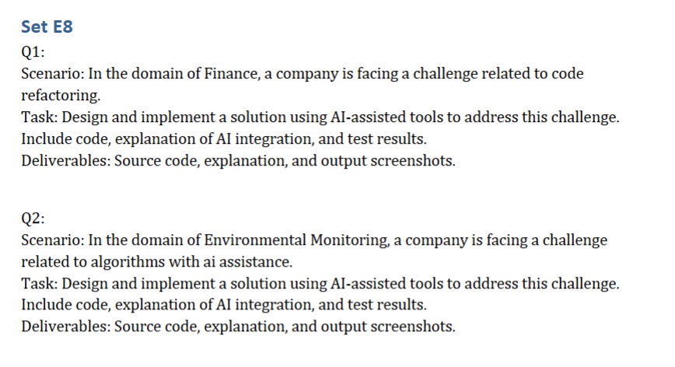

Task-1:

Prompt:

Code:

Output:

Observation:

AI successfully refactored code into modular class structure while preserving all business logic. Generated comprehensive tests and type hints automatically.

Task-2:

Prompt:

Code:

Output:

Observation:

AI generated complex environmental algorithms with accurate AQI calculations and threshold checks. Successfully created a multi-parameter monitoring system that automatically detects pollution levels and generates appropriate alerts